Litha Zenande Christine Mbawu
ST10486617
WEDE5020
WEB DEVELOPMENT

Table of Contents
Table of Contents 1
Building the foundation 2
1.Project Initiation and Planning 2
2. Research and planning 2
2.2 Website Project Proposal 2 – Gift of the Givers Foundation 4
3. CONTENT RESEARCH AND SOURCING 6
4. WEBSITE STRUCTURE AND PLANNING 6
5. HTML STRUCTURE AND BASIC CONTENT 8
6. LEGAL IMAGE AND ASSET SOURCES 9
7. LOW-FIDELITY WIREFRAMES 9
References 15

Building the foundation

1.Project Initiation and Planning
Target Organisation
The organisation selected for this website project is the South African National Blood Service (SANBS). SANBS is an independent non-profit organisation and a leader in the field of blood transfusion. The organisation operates in eight of South Africa's nine provinces, with the Western Cape served by the Western Cape Blood Service. SANBS supplies more than one million blood products annually and processes donated blood into red blood cells, plasma and platelets (SANBS, n.d.).
The proposed website will target first-time and regular blood donors, potential donors, healthcare professionals, hospitals, schools, businesses, community organisations, sponsors and members of the general public.
The main goal of the project is to create a modern, informative and easy-to-navigate website that makes it easier for members of the public to understand blood donation, locate donation centres and become involved with SANBS.

2. Research and planning
2.1 Website Project Proposal 1 – SANBS
1. Organisation Overview
The South African National Blood Service (SANBS) is an independent non-profit organisation and a leader in blood transfusion services. SANBS operates in eight of South Africa's nine provinces and provides support to other countries in the SADC region. The organisation supplies more than one million blood products annually and uses testing and collection protocols to ensure the safety and quality of donated blood (SANBS, n.d.).
SANBS's purpose is “Trusted to save lives.” Its vision is to be the cornerstone of healthcare services in South Africa through the gift of life. Its mission is to reliably provide trusted blood products and services to patients while maintaining appropriate levels of cost, efficiency and quality and innovating to improve patient outcomes (SANBS, 2025).
The target audience includes first-time and regular blood donors, potential donors, healthcare professionals, hospitals, schools, businesses, community organisations, sponsors and the general public.
2. Website Goals and Objectives
The proposed website will aim to increase public awareness and participation in blood donation by making important information easier to find.
The main objectives are to:
Increase online donor engagement.
Encourage first-time blood donors.
Make donor-centre information easier to access.
Educate visitors about blood donation.
Encourage organisations to arrange blood drives.
Provide clear information about SANBS services.
Key Performance Indicators (KPIs):
Increase website traffic by 20% within six months.
Increase donation-related enquiries by 20%.
Increase visits to the donor-centre finder.
Increase engagement with donor eligibility information.
Increase blood-drive enquiries.
These objectives are aligned with SANBS's need to maintain a sufficient blood supply. SANBS states that it aims to collect approximately 3,500 units of blood per day to meet demand and maintain reserve stock (SANBS, n.d.).
3. Current Website Analysis
The current SANBS website provides important information about blood donation, donor centres, blood drives, eligibility, donation processes and blood products (SANBS, n.d.).
However, the proposed redesign will focus on improving the user experience by creating a clearer visual hierarchy, simpler navigation, prominent calls-to-action and a stronger mobile-first design.
The proposed website will make key actions such as finding a donor centre, learning about eligibility and making an enquiry easier to locate.
4. Proposed Features and Functionality
The proposed website will include:
Homepage
About Us
Services
Enquiry
Contact
Blood donation information
Blood-stock information
Blood products
Donor-centre information
Blood-drive information
Volunteer and sponsorship enquiries
SANBS produces various blood products, including red-cell, platelet and plasma products, which are manufactured according to required quality standards (SANBS, n.d.).
Advanced functionality such as donor accounts, databases, APIs and personalised donor dashboards will be considered future functionality rather than requirements for this prototype.
5. Design and User Experience
The website will use a colour scheme inspired by SANBS's existing branding.
Colour scheme:
SANBS Red
Charcoal
White
Light Grey
Typography:
Headings: Montserrat
Body: Open Sans
The website will use a clean layout, large headings, strong colour contrast, accessible navigation and prominent calls-to-action such as:
Donate Blood
Find a Centre
Am I Eligible?
Get Involved
The website will also be designed to work across desktop, tablet and mobile devices.
Low-fidelity wireframes will be created before development to demonstrate the layout and information hierarchy.
6. Technical Requirements
The prototype will be developed using:
HTML5
CSS3
JavaScript
Visual Studio Code
GitHub
The project will initially be developed as a static website. Advanced backend systems, databases and APIs may be considered in future development.
7. Timeline and Milestones

Phase | Dates | Deliverables
Planning & Wireframes | 4–17 August | Research, sitemap and wireframes
UI/UX Design | 18 August–7 September | Visual design and layouts
Development | 8 September–5 October | HTML, CSS and JavaScript
Testing | 6–19 October | Testing and corrections
Compliance Review | 20–24 October | Accessibility and content review
Final Launch | 27–31 October | Final submission

8. Budget

Item | Estimated Cost
Visual Studio Code | R0
GitHub | R0
HTML/CSS/JavaScript | R0
Free image/asset tools | R0
Domain | R100–R200/year
Basic hosting | R100–R300/month
Maintenance | R500–R1,500/month

2.2 Website Project Proposal 2 – Gift of the Givers Foundation
1. Organisation Overview
The Gift of the Givers Foundation is a humanitarian organisation of African origin that provides assistance to vulnerable communities during disasters and humanitarian crises. The organisation was established in 1992 and provides assistance regardless of race, religion, colour, class, political affiliation or geographical location (Gift of the Givers Foundation, n.d.).
Its activities include disaster response, hunger alleviation, water provision, healthcare, education and human development (Gift of the Givers Foundation, 2022).
The target audience includes donors, volunteers, corporate partners, community organisations, people seeking assistance and members of the general public.
2. Website Goals and Objectives
The proposed website would make it easier for visitors to understand the organisation's humanitarian work and support its projects.
The objectives would be to:
Increase online donations.
Increase volunteer enquiries.
Improve access to humanitarian project information.
Increase awareness of emergency campaigns.
Improve communication with donors and partners.
KPIs:
Increase website traffic by 20% within six months.
Increase online donation interactions by 15%.
Increase volunteer enquiries by 20%.
Increase newsletter subscriptions.
Increase engagement with humanitarian campaigns.
3. Current Website Analysis
The existing website provides information about the organisation's projects, humanitarian activities, donation opportunities and programmes. Its work includes disaster response, hunger alleviation, water provision, healthcare, education and human development (Gift of the Givers Foundation, 2022).
The proposed redesign would focus on improving the organisation of information through clearer navigation, stronger calls-to-action and a consistent visual design.
4. Proposed Features
The proposed website would contain:
Homepage
About Us
Humanitarian Services
Current Appeals
Volunteer/Enquiry page
Donation information
Contact page
Project information
News and updates
5. Design and User Experience
The website would use:
Red
White
Dark grey
Light neutral backgrounds
Prominent buttons such as Donate, Volunteer and Get Help would allow visitors to quickly identify the most important actions.
6. Technical Requirements
The prototype would use:
HTML5
CSS3
JavaScript
Visual Studio Code
GitHub
A future version could include a content management system and online donation integrations.
7. Timeline
The project would follow the same planning, design, development, testing and submission schedule as the SANBS proposal.
8. Budget
Item | Estimated Cost
Development software | R0
Github | R0
Domain | R100-R200/year
Hosting | R100-R300/month
Maintenance | R100-R1500/month

3. CONTENT RESEARCH AND SOURCING
3.1 SANBS Research
The SANBS official website will be the primary source for organisational information.
Research will cover:
Organisation history
Purpose
Mission
Vision
Blood donation requirements
Donation process
Blood products
Donor centres
Blood drives
Blood-stock information
Contact information
Donor stories
According to SANBS, first-time donors must generally be between 16 and 75 years old, weigh at least 50 kg, be in good health and meet the organisation's other donation requirements. The donation process includes completing a questionnaire, an individual interview, providing consent and undergoing health checks such as blood pressure and haemoglobin assessment before donation. SANBS explains that donated blood is separated into components including red blood cells, plasma and platelets, meaning that one donation can potentially help up to three patients. SANBS also provides a donor-centre search function to help donors find convenient places to donate blood (SANBS, n.d.).

4. WEBSITE STRUCTURE AND PLANNING
4.1 Sitemap
SANBS Sitemap
SANBS Website
Homepage
About Us
- Mission

About Us
Homepage

SANBS Website

Contact

Call
Blood products & Services

email

Why to donate
Mission
Where to donate?
Blood stock levels

4.2 File and Folder Structure
SANBS-Website/
│
├── index.html
├── about.html
├── services.html
├── enquiry.html
├── contact.html
│
├── css/
│ └── style.css
│
├── js/
│ └── script.js
│
├── images/
│ ├── logo/
│ ├── hero/
│ ├── donation/
│ └── icons/
│
├── documents/
│ ├── proposal/
│ └── research/
│
└── README.md

5. HTML STRUCTURE AND BASIC CONTENT
The website will contain a minimum of five HTML pages:
index.html
about.html
services.html
enquiry.html
contact.html
Each page will use semantic HTML elements such as:
<header>
<nav>
<main>
<section>
<article>
<footer>
The pages will be linked through a consistent navigation menu.
5.3 CONTENT INTEGRATION
The researched content will be integrated into the website using appropriate headings, paragraphs, lists, images and links.For example, information about blood-donation eligibility will be based on SANBS's official donor requirements. Information about blood products will be based on SANBS's official blood-products information. Contact information will be obtained from the official SANBS contact page.
5.4 CONTACT PAGE
The Contact page will contain more than one SANBS location.
The main SANBS contact information will include:
Tel: 011 761 9000
Email: customerservice@sanbs.org.za
Additional donor-centre locations will be displayed on the page. For example, SANBS lists the Greenstone Donor Centre at Greenstone Shopping Centre in Johannesburg (SANBS, n.d.).
This satisfies the assignment requirement that the Contact page contain more than one location.
5.5 ENQUIRY PAGE
Because SANBS is a non-profit organisation, the enquiry form will include opportunities for visitors to become involved.
The form will include:
Name
Surname
Email
Phone Number
Message
[ SUBMIT ENQUIRY ]

The blood-drive option is particularly relevant because SANBS encourages organisations such as schools, businesses, churches and community groups to organise blood drives (SANBS, n.d.).

6. LEGAL IMAGE AND ASSET SOURCES
Images and other assets will be sourced legally.
Potential sources include:
SANBS official website
The project will maintain an asset register documenting the source and licence/permission for each external image or asset.

7. LOW-FIDELITY WIREFRAMES
Use the SANBS colour palette:
PINK, RED, BLACK, WHITE, LIGHT GREY

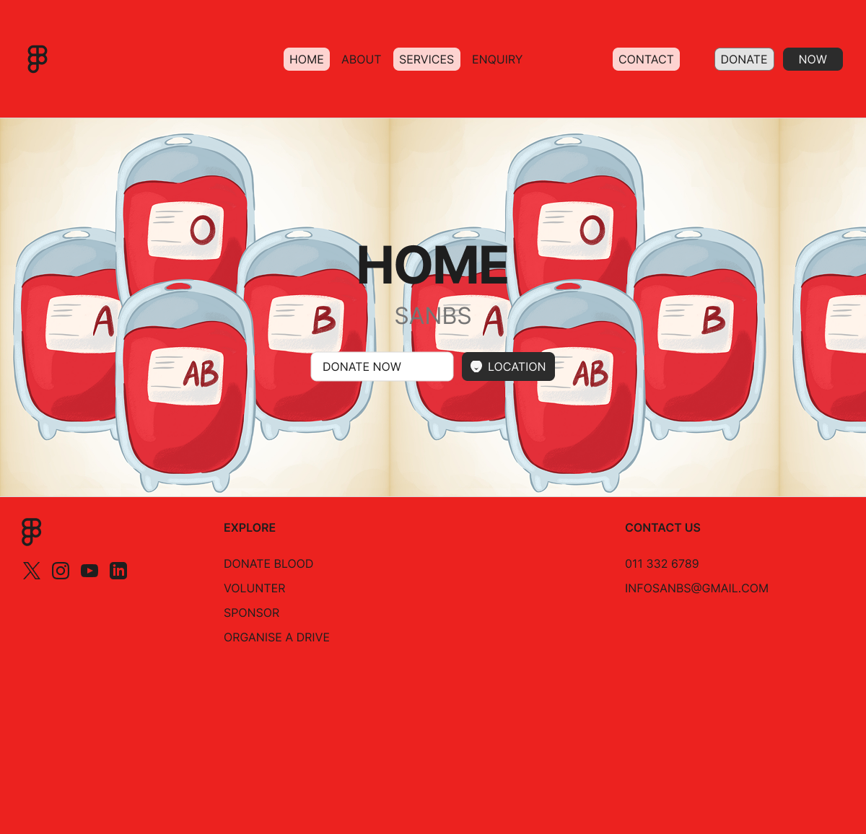
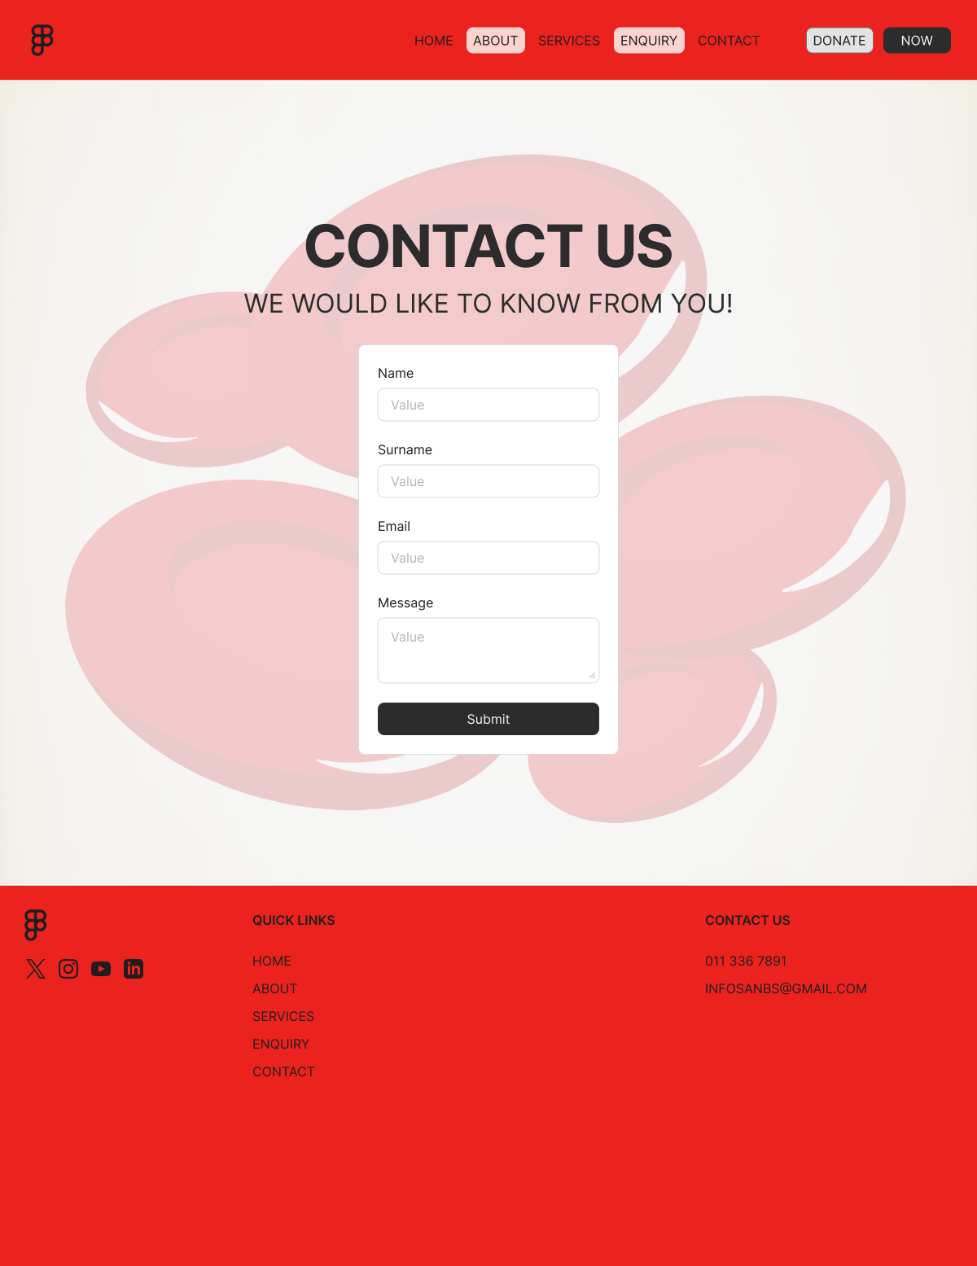
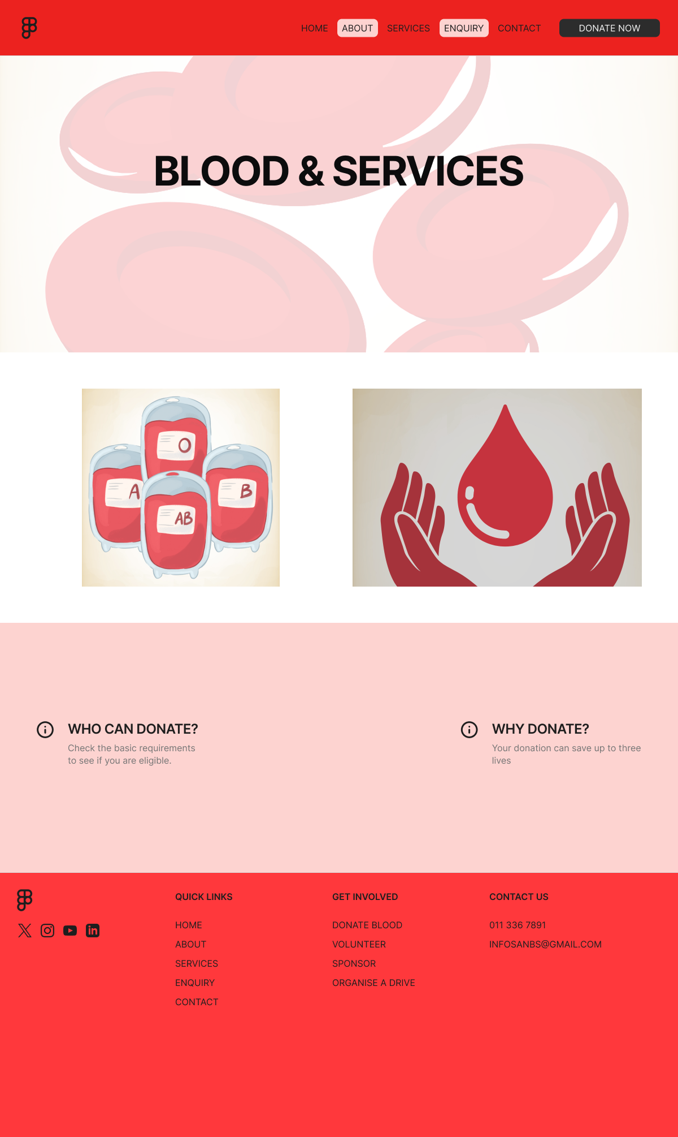
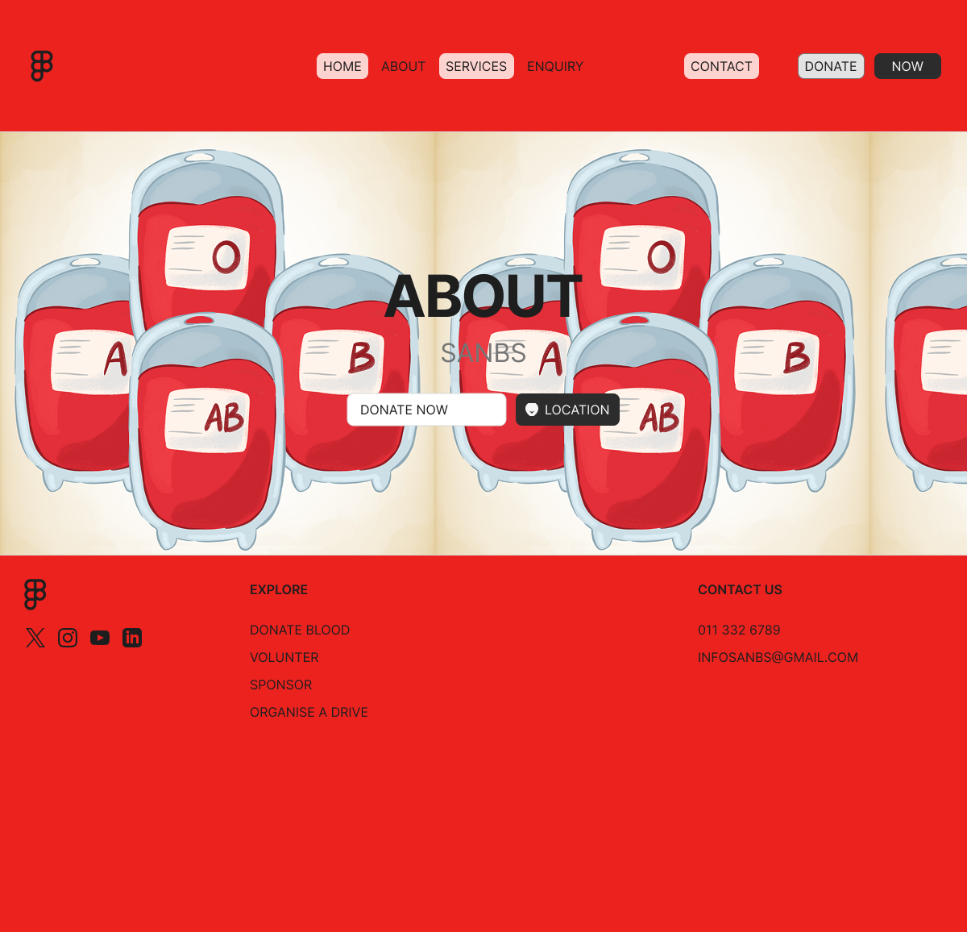
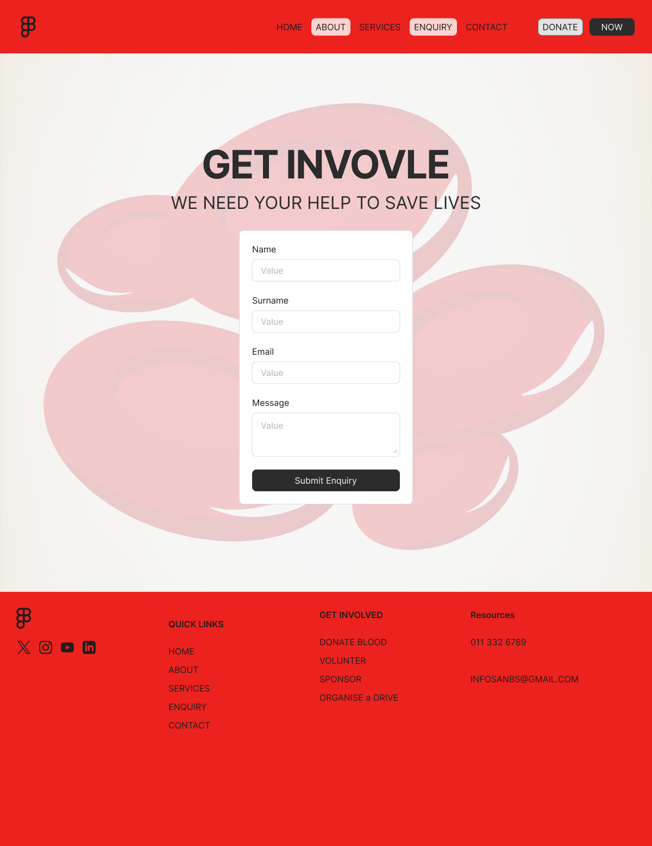

References
Gift of the Givers Foundation (2022) What we do. Available at: official Gift of the Givers website (Accessed: 21 August 2026).
South African National Blood Service (SANBS) (2025) Our purpose, vision, mission, values and mandate. Available at: official SANBS website (Accessed: 21 August 2026).

